Project Design Phase-I - Solution Fit Template Project Title: Developing a flight delay model using Machine Learning

Team ID: PNT2022TMID52685

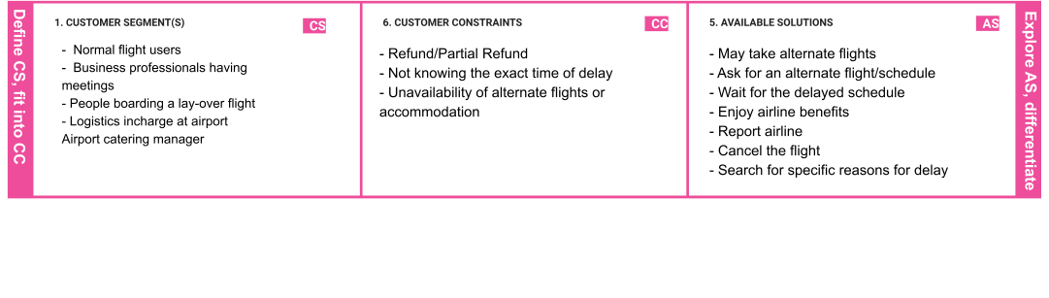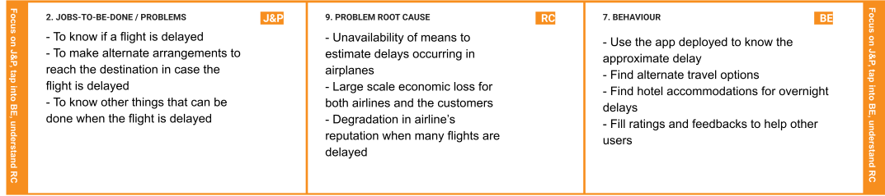

|  |  |  |  |  |
| --- | --- | --- | --- | --- |
|  | 1. **TRIGGERS**   **TR**   * + Cancellation of flights   + Extreme boredom   + Guilt of wasting time   + Thought of missing important meetings   + Missing layover flight   + Uncertainty in deciding if the flight is delayed when they start late for the airport | **10. YOUR SOLUTION SL**  - The aim is to develop an application that predicts flight delays using a supervised machine learning model (a decision tree classifier) with the data of flights and delays so far and estimate the time of delay taking spatial dependencies of flights into account. | 1. **CHANNELS of BEHAVIOUR**   **CH**   * 1. **ONLINE** * Check if a particular flight will be delayed and the estimated time of arrival * Giving ratings and feedbacks for various flights so as to improve the app’s performance in predicting further delays * Check for other specific reasons for delay |  |
|  | 1. **EMOTIONS: BEFORE / AFTER**   **EM**  Before:   * + Worried     - About missing important events     - About missing layover flights     - If the flight is gonna be canceled   + Frustrated     - About the unexpected delay/cancellation     - Not knowing the news of delay beforehand     - About the weather   + Bored     - Don't know how to make use of time   After:   * + Gets to enjoy the airline benefits   + Stay relaxed after getting a proper update from the airline   + Relieved if an alternate solution can be   found |  | **8.2 OFFLINE**   * Finding alternate travel routes in the airport * Hotels near the airport can be visit for overnight stays during delays |  |

